Project Report

**1. INTRODUCTION**

1.1 Overview

Estimating business expenses is a fundamental aspect of financial planning and decision-making for any enterprise. It involves a systematic assessment and projection of the costs and financial requirements associated with various business activities, projects, or expansions. Accurate expense estimation is crucial for effective budgeting, ensuring financial sustainability, and making informed strategic decisions. This process enables businesses to allocate resources efficiently, identify potential financial challenges, and ultimately, achieve their short-term and long-term goals. In this report, we will delve into the process of estimating business expenses, examining its significance, methodologies, and the impact it has on the overall financial health and success of a business.

1.2 Purpose

The purpose of estimating business expenses is multifaceted and plays a crucial role in the financial management and success of a business. Here are some key purposes for estimating business expenses:

1. **Budget Planning:** Estimating expenses is essential for creating and maintaining a comprehensive budget. A well-defined budget allows businesses to allocate resources efficiently and plan for future expenditures.

2. **Financial Control:** Expense estimation helps in controlling and managing financial resources. By forecasting expenses, businesses can identify areas where cost-saving measures are necessary.

3. **Decision-Making:** Accurate expense estimates are vital for informed decision-making. They provide insights into the financial feasibility of projects, expansions, and investments, enabling management to make sound choices.

4. **Profitability Analysis:** Estimating expenses aids in analyzing the cost structure of the business. It helps in assessing whether the revenue generated is sufficient to cover operational costs and generate profits.

5. **Risk Management:** Expense estimation helps in identifying potential financial risks and challenges. By understanding anticipated expenses, businesses can proactively develop risk mitigation strategies.

6. **Resource Allocation:** It assists in determining the allocation of resources, such as personnel, time, and capital, for specific projects or departments within the organization.

7. **Performance Evaluation:** By comparing estimated expenses to actual costs, businesses can evaluate their financial performance. This enables them to adjust their strategies, control costs, and improve profitability.

8. **Investor and Stakeholder Communication:** Transparent and accurate expense estimation is vital for communicating with investors, stakeholders, and creditors. It instills confidence and transparency in financial reporting.

9. **Compliance:** Accurate estimation is essential for complying with financial reporting and taxation requirements. It helps ensure that the business is meeting its legal obligations.

10. **Strategic Planning:** Expense estimation is integral to strategic planning. It guides businesses in setting financial goals, growth targets, and future initiatives.

11. **Resource Efficiency:** By estimating expenses, businesses can optimize their resource utilization, minimize waste, and operate more sustainably.

In summary, estimating business expenses is a fundamental financial practice that aids businesses in financial planning, cost control, risk management, and overall strategic decision-making. It is a critical component of maintaining the financial health and sustainability of a business.

**2. PROBLEM DEFINITION & DESIGN THINKING**

2.1 Empathy map

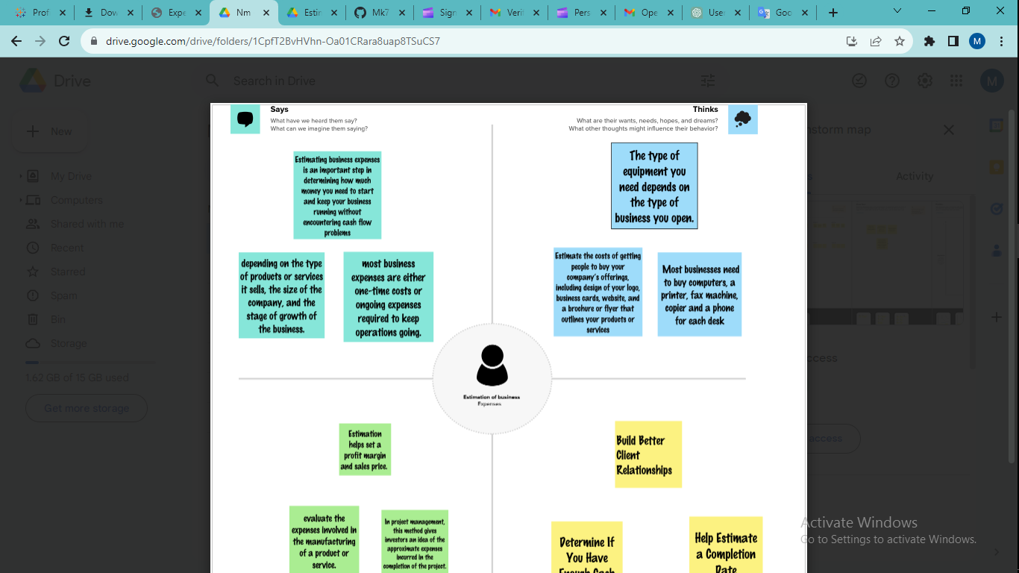

2.2 Ideation & Brainstorming Map

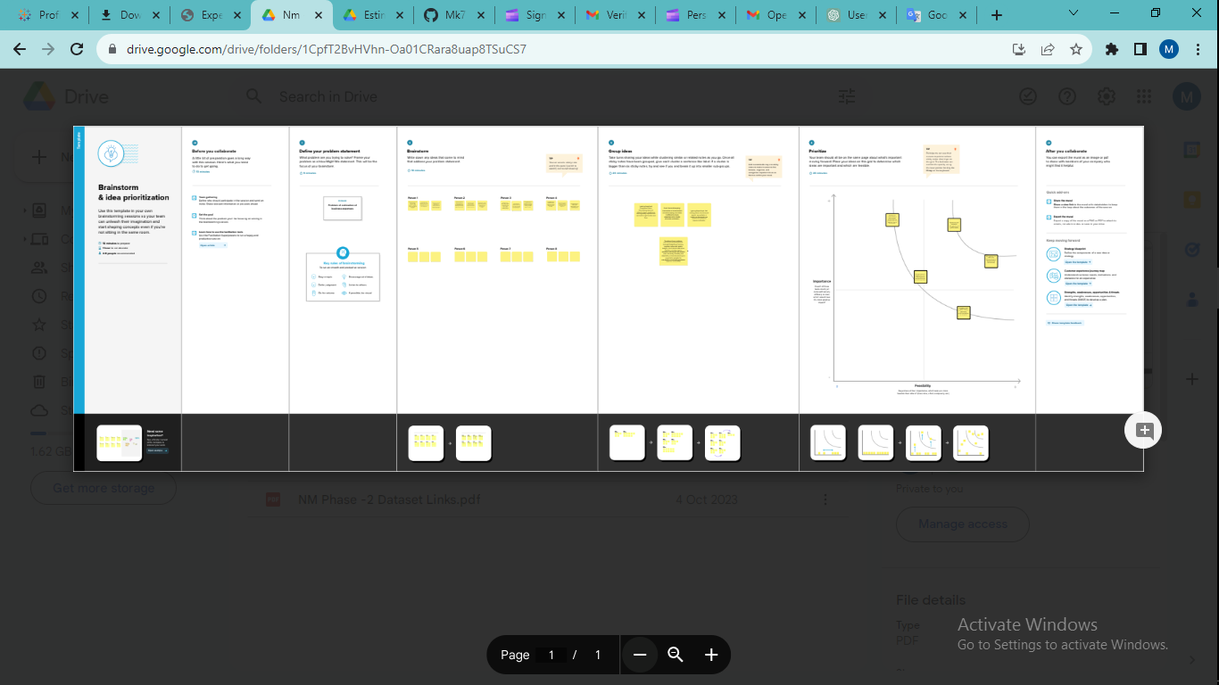

**3. RESULT**

Present the estimated business expenses for the planned expansion.

Categorize expenses as one-time, fixed operating, variable operating, marketing, human resources, and technology/equipment expenses.

Include itemized costs, vendor information, payment schedules, and a contingency budget.

Use tables, graphs, and charts to illustrate the expense estimates clearly.

**4. ADVANTAGES & DISADVANTAGES**

Advantages:

* Discuss the advantages and benefits of having a well-structured expense estimation:
  + Better financial planning.
  + Improved allocation of resources.
  + Minimized financial risks.
  + Enhanced decision-making.
* Explain how these advantages can positively impact the business.

Disadvantages:

* Highlight potential drawbacks and challenges related to expense estimation:
  + Inaccuracy in estimates.
  + Limited flexibility in adapting to unforeseen changes.
  + Overestimation or underestimation of expenses.
* Offer insights into how these disadvantages can be mitigated.

**5. APPLICATIONS**

* + Describe how the estimated expenses will be applied in the context of your business expansion.
  + Explain how the estimates will inform your budget and financial planning.
  + Discuss how they will guide resource allocation and decision-making throughout the expansion.

**6. CONCLUSION**

* + Summarize the key findings and insights from the expense estimation project.
  + Reiterate the importance of accurate estimation for a successful expansion.
  + State whether the project's objectives were met.

**7. FUTURE SCOPE**

* Discuss potential areas for further research or improvements related to business expense estimation:
  + The use of advanced financial modeling tools.
  + Enhancing accuracy through real-time data analytics.
  + The application of machine learning or AI for predictive expense estimation.
* Explain how these future prospects could positively impact your business and its expansion.